**WEEK-5**

**Problem statement:**

**1.Introduction to Modern Javascript and DOM**

1(a).Write a JavaScript program to link JavaScript file with the HTML page

**Description:**

In this experiment, we create a simple HTML page and connect it with an external JavaScript file using the <script> tag. The HTML file (index.html) contains a button, and when the button is clicked, it calls a JavaScript function defined in the external file (script.js). This function displays an alert message on the screen.

By separating JavaScript into an external file, we keep the HTML structure clean, make the code easier to manage, and allow reusability of scripts across multiple web pages.

**Source code:**

<html>

<head>

<title>Linking JavaScript Example</title>

</head>

<body>

<h1>Welcome to My Page</h1>

<button id="myButton">Click Me!</button>

<p id="message"></p>

<!-- Linking the external JavaScript file -->

<script src="script.js"></script>

</body>

</html>

**script.js**

*// Add an event listener to the button*

document.getElementById("myButton").addEventListener("click", function() {

document.getElementById("message").innerText = "Button clicked! Hello from JavaScript!";

});

**OUTPUT:**

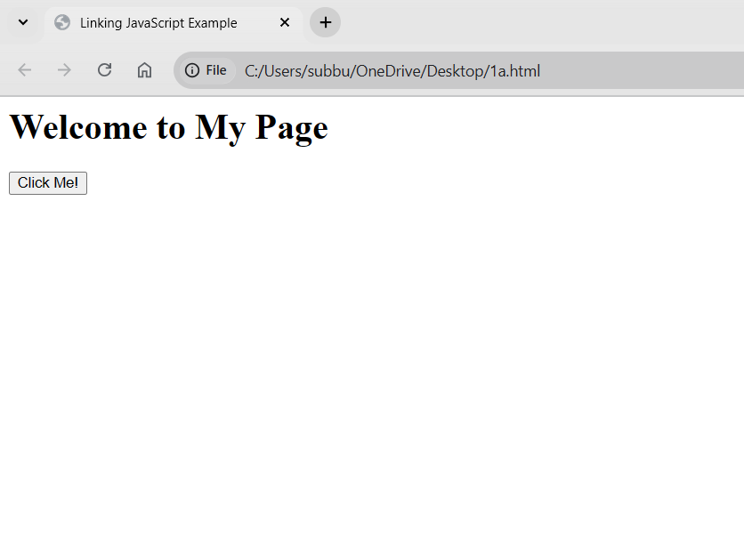

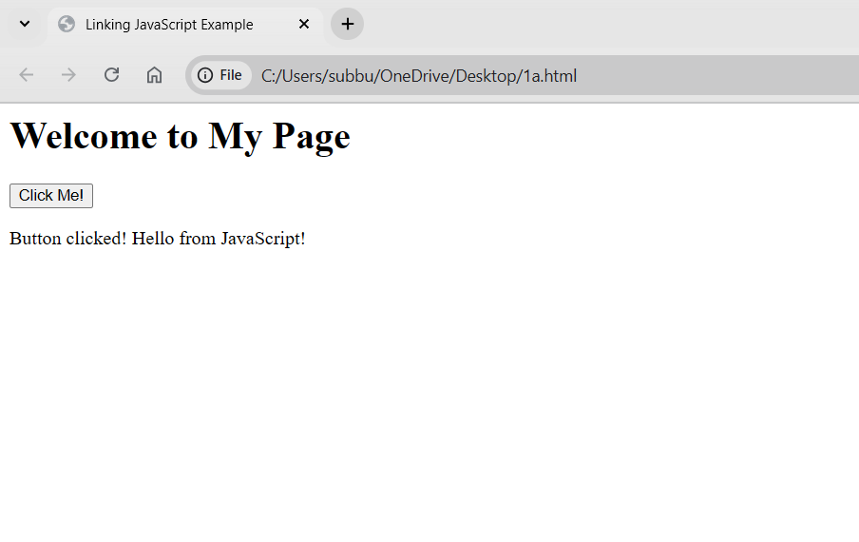

**Problem statement:**

**1(b). Write a JavaScript program to select the elemets in HTML page using selectors**

**Description:**

JavaScript provides several ways to select elements from an HTML document so that we can read, modify, or update them dynamically.

1.getElementById("id") – Selects an element by its unique ID.

2.getElementsByClassName("className") – Selects all elements with a specific class (returns an HTMLCollection).

3.getElementsByTagName("tag") – Selects all elements with a given tag name.

4.querySelector("CSS selector") – Selects the *first* element that matches the given CSS selector.

5.querySelectorAll("CSS selector") – Selects *all* elements that match the given CSS selector (returns a NodeList).

These selectors are used widely in DOM (Document Object Model) manipulation to make webpages interactive.

**Source code:**

<html>

<head>

<title>DOM Selectors Example</title>

<style>

.highlight {

background-color: yellow;

}

</style>

</head>

<body>

<h1 id="mainHeader">Welcome to DOM Selectors</h1>

<p class="text">This is the first paragraph.</p>

<p class="text">This is the second paragraph.</p>

<button id="changeButton">Change Content</button>

<script src="selectors.js"></script>

</body>

</html>

**selectors.js**

// Select elements when the button is clicked

document.getElementById("changeButton").addEventListener("click", function() {

// 1. Select by ID

const header = document.getElementById("mainHeader");

header.innerText = "Header Changed!";

// 2. Select by Class (first element) using querySelector

const firstParagraph = document.querySelector(".text");

firstParagraph.innerText = "First paragraph updated!";

// 3. Select all elements with class 'text' using querySelectorAll

const allParagraphs = document.querySelectorAll(".text");

allParagraphs.forEach((p, index) => {

p.classList.add("highlight"); // Add highlight class

p.innerText = `Paragraph ${index + 1} updated!`;

});

});

**OUTPUT:**